Tagungsbeitrag (Poster):
Jahrestagung der DBG - Kommission II, Nährstoffe in Böden
Titel der Tagung:
Unsere Böden - Unser Leben
Veranstalter:
DBG, 05. – 10. Sep. 2015, München
Berichte der DBG
http://www.dbges.de

Placement of Pseudomonas sp. DSMZ13134 around NH₄⁺-based fertilizer depots in maize stimulates root exploitation of the fertilizer depot in soil
Nkebiwe P M ¹, Weinmann M², Weber N², Neumann G², Müller T ¹
Summary
Plant P-acquisition from soil can be improved by rhizosphere acidification induced by exudation of protons or organic acids in neutral to alkaline soils, increased root growth and plant growth-promoting microorganisms (PGPMs). Our objective was to investigate the effect of stabilized NH₄⁺-fertilizer placed as a subsoil depot and PGPM inoculated in and around the NH₄⁺-depot zone on root growth, rhizosphere pH, root-colonization by PGPM around the NH₄⁺-depot-zone, shoot N and P content, and yield. The test crop was maize (Zea mays L.).

At 8 weeks after sowing on an alkaline low-P soil contained in rhizoboxes, higher root length density, lower rhizosphere pH and higher Pseudomonas sp. colonization rate was observed in the NH₄⁺-depot zone in comparison to the corresponding soil zone in controls supplied homogenously with NO₃⁻. Shoot N and P in plants fertilized __________________________________
¹ Fertilisation and Soil Matter Dynamics (340 i) ²Nutritional Crop Physiology (340 h) University of Hohenheim, Fruwirthstraße 20, 70599 Stuttgart, Germany Email: Mehdi.Nkebiwe@uni-hohenheim.de
with N as an NH₄⁺-depot was higher than those in plants fertilized homogenously with NO₃⁻. There was no difference in shoot weight and there was no PGPM effect on shoot growth.
In two field experiments (2014 and 2015) on a neutral silt loam with moderate P availability, root length density was higher in the NH₄⁺-depot-side of maize rows compared to opposite sides without an NH₄⁺-depot, irrespective of PGPM treatment. In 2014 only, inoculation of Pseudomonas sp. PRORADIX DSMZ13134 led to doubling of root length density in the NH₄⁺-depot zone. This indicated improved root exploitation of the fertilizer depot induced by PGPM inoculation under field conditions. This effect could not be reproduced in 2015 possibly due to severe drought stress. Yield of grain (2014) and silage (2015) were neither affected by placement of subsoil NH₄⁺-depot nor inoculation with PGPMs, likely due to moderate to optimal initial levels of N and P in the field sites.

Keywords: Fertilizer placement, Ammonium-depot, Root growth, P mobilization, PGPM, P-solubilizing bacteria

Background
Low plant-availability of P is commonly a limiting factor in many crop production systems¹. Subsurface placement of NH₄⁺-based fertilizers as a depot in soil induces intense localized root growth and rhizosphere acidification² around the depot, which together enhance plant P-acquisition in neutral to alkaline soils. The rhizosphere „hotspot“ with dense rooting and high levels of root exudates created around such an NH₄⁺-depot may enhance root colonization by plant growth-promoting microorganisms (PGPMs), which in turn promote further root growth³, mineralization and solubilization of nutrients such as P⁴ and mycorrhization⁵. Using maize (Zea mays L.) as test crop, our objective was to investigate the effect of N fertilization as a subsurface NH₄⁺-depot and inoculation of the most promising PGPMs (based on previous plating tests for P-solubilization and NH₄⁺-tolerance) on root growth, rhizosphere pH, PGPM colonization, yield and shoot N and P content.

Materials und Methods
Rhizobox: We cultivated maize (Zea mays L. var Colisee, KWS, Germany) under adequate supply of N (150 mg), P (100 mg), K (150 mg) (each per kg soil D.M), micronutrients and H₂O (60 % max. WHC). The substrate was based on 80 % low-P loess subsoil (P_{CAL}, 5 mg kg⁻¹; pH (CaCl₂), 7.6) and 20 % quartz sand (0.6-1.2 mm Ø) by weight. Treatments included combinations of two N levels (Homogenous application of CaNO₃ and Placement of concentrated (NH₄)₂SO₄, fertilizer⁶ stabilized with 3,4-Dimethylpyrazole phosphate (3,4-DMPP)⁷, 64 mg N ml⁻¹, 5 X 5 cm to the side and below the maize seed) and two PGPM levels (No inoculation and inoculation with Pseudomonas sp. PRORADIX DSMZ13134 (Sourcon Padena, Tübingen, Germany) at the rate 2 x 10⁶ CFUs g⁻¹ soil D.M. around the NH₄⁺-depot zone or corresponding soil zone in NO₃⁻ treatments). There were 4 replicates per treatment arranged in a completely randomized design (16 h light at 25°C and 8 h. darkness, 18 °C). Rhizobox dimension was 40 X 20 X 2 cm (H x W x D).

Field: In 2014 and 2015, we cultivated maize (Zea mays L. var Colisee) on soil with moderate P availability at the research station of the University of Hohenheim, Ihinger Hof, Renningen, Germany (48°44'42.3"N 8°55'26.7"E; 475 m above sea level; 688 mm av. annual rainfall; 8.8 °C mean annual daily temperature, 2014: luvisol and cambisol, 24-28 % clay, 67-72 % silt, 4-5 % sand, pH (CaCl₂) 6.9, C_{org}, 1 %, N_{min}, 38 kg ha⁻¹; P_{CAL}, 120 mg kg⁻¹; 2015: luvisol and cambisol, silty loam, pH 7.1, N_{min}, 61 kg ha⁻¹.
NH₄⁺-depot was made by placing concentrated (NH₄)₂SO₄ + 3,4-DMPP (Novatec®solub 21, Compo Expert, Münster, Germany) dissolved in water (2014, 64 mg N ml⁻¹; 2015, 62.7 mg N ml⁻¹) or in pig liquid manure (0.07 % N) (2014 only, 64 mg N ml⁻¹) at a soil depth of 10 cm midway between maize rows in alternating inter-row spaces (6 rows per plot, 75 cm inter-row distance). The rate was 135 kg N ha⁻¹ (2014) and 100 kg N ha⁻¹ (2015).
In 2014, applied PGPMs included: 1.) Trichoderma harzianum T-22 (Koppert B.V., The Netherlands); 2.) Penicillium sp. Biological Fertilizer DC (Bayer Crop Science, Germany); 3.) Pseudomonas sp. PRORADIX DSMZ13134; 4.) Rifampicin-resistant Bacillus amyloliquefaciens FZB 42-RIF (ABiTEP GmbH, Berlin, Germany). A suspension of PGPM in water was broadcast at a rate 1x10⁶ CFU g⁻¹ soil D.M. and immediately incorporated (10 cm) before sowing. PGPM was applied again by banding a water-suspension on the crop row at 2-3 leaf stage. In 2015 only, PGPMs 3 and 4 above were applied (CFUs g⁻¹ soil D.M.) using the following techniques: Broadcast/incorporation (1x10⁶), Below seed placement of inoculated pumice stones (0.13x10⁶) and Seed treatment (0.0008x10⁶) before seeding. At sowing in May, starter fertilizer as mono-ammonium phosphate in 2014 (17 kg N, 35 kg P ha⁻¹) or di-ammonium phosphate in 2015 (29 kg N, 32 kg P ha⁻¹) was placed 5 X 5 cm to the side and below the seed row. Plot sizes were 4.5 m x 9 m = 40.5 m² (2014) and 4.5 m x 13 m = 58.5 m² (2015). Cumulative Apr. - Aug. rainfall was 447 mm (2014) and 279 mm (2015).
In the rhizobox experiment, rhizosphere pH was measured using antimony micro-electrodes⁸. Soil cores were bored out, washed and roots were scanned and analyzed using WinRhizo Pro (Regent Instruments Inc.). PGPM root-colonization was measured by extraction of roots with 1% proteose-peptone solution and plating of sequentially diluted extracts on selective nutrient agar. Shoot N and P concentration were measured using CN elemental analyzer and molybdate-vanadate method⁹ respectively.

Results and discussion
In rhizoboxes at 8 weeks after sowing (WAS), there was higher root length density (RLD) (Fig. 1); lower root surface pH (Fig. 2) and higher colonization by Pseudomonas sp. (Fig. 3) around the NH₄⁺-depot soil-zone compared to the corresponding soil zone in NO₃⁻ treatments. Improved establishment of inoculated PGPM was due to increased RLD and likely high levels of root exudates around the fertilizer depot zone. Maize shoots from NH₄⁺ treatments had higher contents of N and P than those from NO₃⁻ treatments (Tab. 1). Shoot weights were the same and there was no effect of the inoculated PGPM. Increased RLD and rhizosphere acidification contributed to improve N and P uptake.
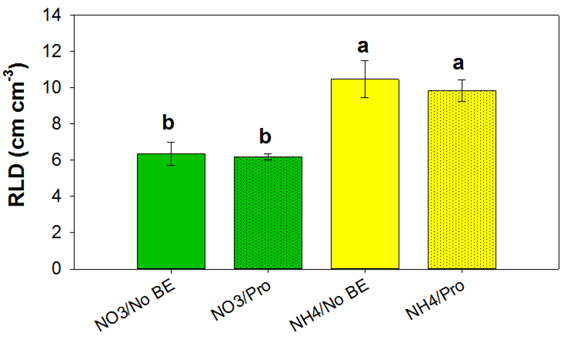
Fig. 1: Root length density (RLD) increased within the soil section 8 cm around the NH₄⁺-depot. Bio-effector had no effect on RLD. (NO3 = CaNO₃ mixed, NH4 = (NH₄)₂SO₄ depot, No BE = Not inoculated, Pro = inoculated with Pseudomonas sp.)
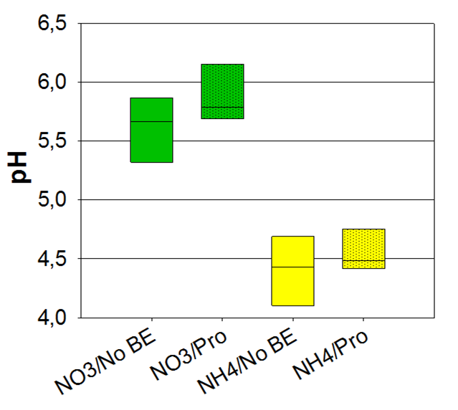 Fig. 2: Root surface pH strongly decreased 8 cm around NH₄⁺-depots.

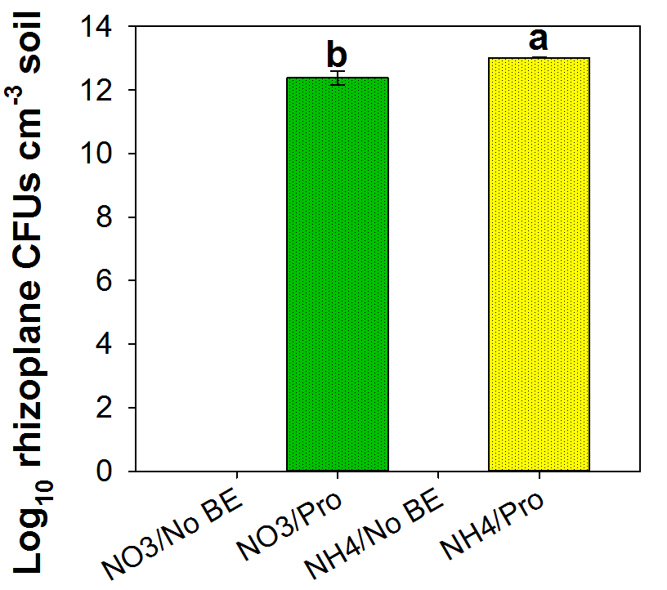
Fig.3: Higher rhizoplane Pseudomonas sp. density in NH₄⁺-depot soil than in NO₃⁻ soil.

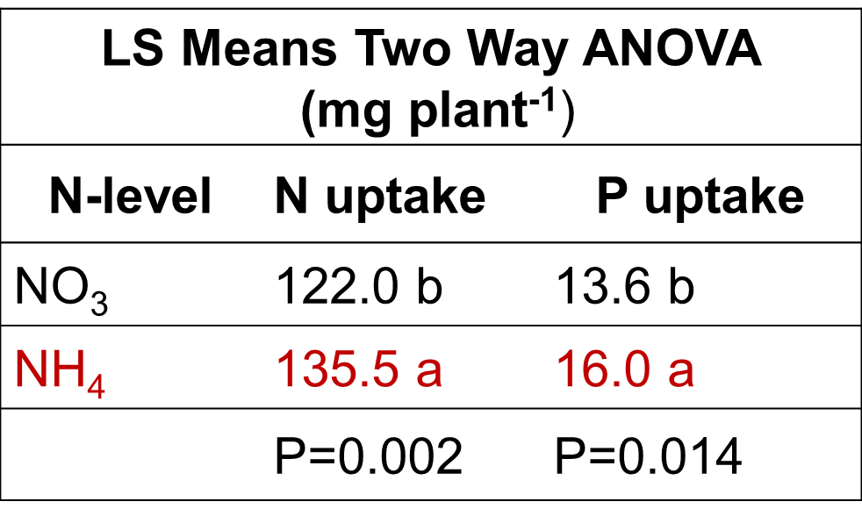
Tab. 1: NH₄⁺placement as a depot led to higher N and P uptake than homogenous supply of NO₃⁻. PGPM had no effect.
In the field experiments, root length density (RLD) was doubled on the side of maize rows with the NH4⁺-depot in comparison to the opposite side without. In 2014 only, RLD in the NH4⁺-depot-zone was higher with inoculation of Pseudomonas sp. PRORADIX DSMZ13134 than without (Fig. 4a. & 4b.). This was probably due to severe drought in 2015. Inoculation of PGPM and inoculation technique did not affect grain yield (2014) and silage yield (2015). Nevertheless, Pseudomonas sp. PRORADIX DSMZ13134 (2014) and Bacillus amyloliquefaciens FZB 42-RIF (2015) was recovered from plant root samples, confirming root colonization. The root colonization rate of the Bacillus was proportional to the inoculation rate (Fig. 5).
Fig. 5: Colonization of rhizosphere soil by Bacillus amyloliquefaciens FZB42-RIF was highest in Broadcast/Incorporation followed by Below-seed placement and then by Seed treatment.
Conclusion
Subsoil placement of NH4⁺ fertilizers induces the formation of rhizosphere „hotspots“ with intense rooting and rhizosphere acidification which promotes N and P uptake. Inoculating soil zones around NH₄⁺-based fertilizer depots with root growth-stimulating and/or P-solubilizing microorganisms may intensify rhizosphere processes and improve root exploitation of fertilizer depots.

References

¹Hinsinger, P. (2001): Bioavailability of soil inorganic P in the rhizosphere as affected by root-induced chemical changes: a review. Plant Soil 237, 173–195.
² Jing, J., Rui, Y., Zhang, F., Rengel, Z., Shen, J. (2010): Localized application of phosphorus and ammonium improves growth of maize seedlings by stimulating root proliferation and rhizosphere acidification. Field Crop. Res. 119, 355–364.
³ Mohite, B. (2013): Isolation and characterization of indole acetic acid (IAA) producing bacteria from rhizospheric soil and its effect on plant growth. J. soil sci. plant nutr. 13, 638–649
⁴ Vassilev, N., Vassileva, M., Nikolaeva, I. (2006): Simultaneous P-solubilizing and biocontrol activity of microorganisms: potentials and future trends. Appl. Microbiol. Biot. 71, 137–144.
⁵ Richardson, A. E., Barea, J.-M., McNeill, A. M., Prigent-Combaret, C. (2009): Acquisition of phosphorus and nitrogen in the rhizosphere and plant growth promotion by microorganisms. Plant Soil 321, 305–339.
⁶Sommer, K. (2005): CULTAN-Düngung: Physiologisch, ökologisch, ökonomisch optimiertes Düngungsverfahren für Ackerkulturen, Grünland, Gemüse, Zierpflanzen und Obstgehölze Verlag Th. Mann, Gelsenkirchen-Buer, Germany.
⁷Zerulla, W., Barth, T., Dressel, J., Erhardt, K., Horchler von Locquenghien, K., Pasda, G., Rädle, M., Wissemeier, A. (2001): 3,4-Dimethylpyrazole phosphate (DMPP) - a new nitrification inhibitor for agriculture and horticulture. Biol. Fert. Soils 34, 79–84.
⁹Schaller, G., Fischer, W. R. (1985): pH-Änderungen in der Rhizosphäre von Mais- und Erdnußwurzeln. Z. Pflanzenernaehr. Bodenk. 148, 306–320
⁹Gericke, S., Kurmies, B. (1952): Colorimetrische Bestimmung der Phosphorsäure mit Vanadat-Molybdat. Z. Anal. Chem. 137, 15-22

Acknowledgment
This study was funded by the European Community's Seventh Framework Program (FP7/2007-2013) under grant agreement n° 312117 (BIOFECTOR).

